1.90: From Eq. (1.27), the cross product is

The magnitude of the vector in square brackets is 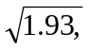 and so a unit vector in this direction (which is necessarily perpendicular to both 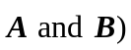 is

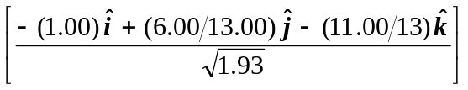.

The negative of this vector,

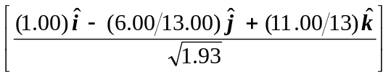,

is also a unit vector perpendicular to 

